Compressed Gases
Here is some UPDATED information on using and storing compressed gas cylinders | - Compressed cylinders can now be delivered to both SE1 and SE2. If cylinders are not being delivered to the correct building, please notify your purchasing agent when orders are placed.  - In SE2, the new cylinder storage area is located on the first floor, across from the freight elevator in room 104. Please keep empties on the right, inerts on the left (Ar, N₂, CO₂), and flammables in 104A.  - Keep all compressed gas cylinders chained to the wall or cylinder rack at all times. When cylinders are not in use (no regulator is attached), a cylinder cap must be in place. The photo is an example of a condition that must be corrected. OSHA can levy fines for this.  - Any piping that penetrates walls must be labeled on both sides with the name of the gas.  - In setups, use braided tubing and Swagelok connections from regulators whenever possible, and do not exceed the design pressure of the system.  - When moving cylinders, always chain the tank to a cylinder cart. Never move a cylinder without the cap in place.  - Do not block electrical panels with tanks, or place them in areas where they could become electrically energized.  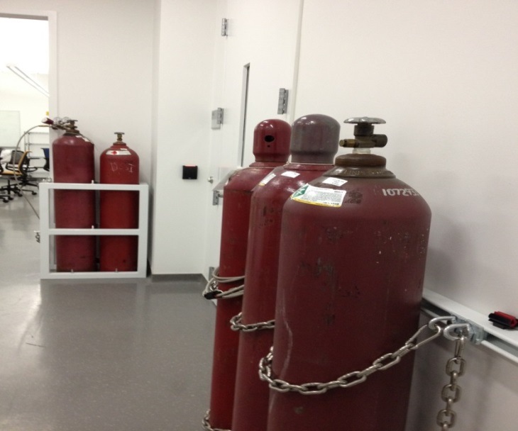  - Never store liquid nitrogen dewars or dry ice boxes in cold rooms, due to the risk of asphyxiation.

