Compressed Gas Storage
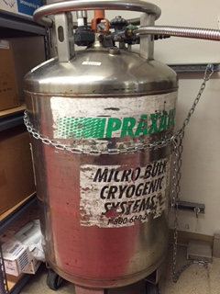  Chain your cylinders!  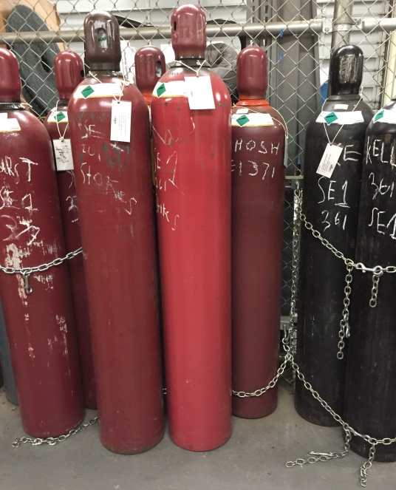 | - Liquid Nitrogen dewars must now be chained to the wall, as demonstrated on the left. Place a work order with fmhelp.ucmerced.edu if you need materials or installation.  - A dewar cart is now available for you to move dewars without wheels to the empty cylinder area.  - If you remove a cylinder from a group or nest, remember to re-chain the cylinders left behind. Do not leave them as in the bottom left photo. Use two chains (shown in blue) – one on top and one on bottom.  - Your chemical inventory now reflects cylinders you have in the loading dock as well as what is in the lab. Please keep this inventory accurate by moving cylinders to your lab room in the chemical inventory system (CIS).  - Room 144 or 104A are receiving locations, not storage locations. Do not order more cylinders than you can store in your lab. Full cylinders should only be stored in 144 or 104A for a week.

