Item | Picture | Link
Cell culture media | 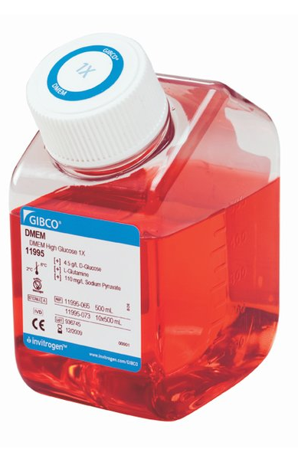 | https://www.fishersci.co.uk/shop/products/gibco-dmem-high-glucose-pyruvate-8/p-4919836
Agar plate | 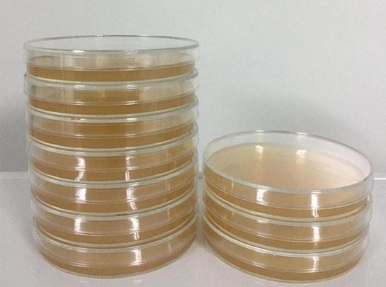 | https://greenbioresearch.com/culture-bacteria-using-pre-made-nutrient-agar-plates/
experimental mice | 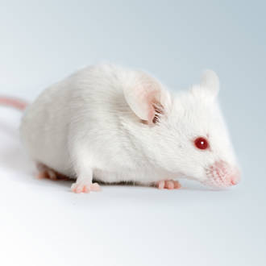 | https://www.jax.org/jax-mice-and-services/find-and-order-jax-mice
Blood in tubes | 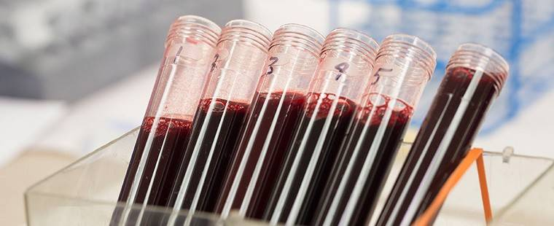 | https://www.redcrossblood.org/content/dam/redcrossblood/rcoassets/neutrophil-labs-hna-nomenclature.jpg.transform/1288/q70/feature/image.jpeg
Syringe |  | https://images-na.ssl-images-amazon.com/images/I/214WrI0+yLL._AC._SR360,460.jpg
Razor | 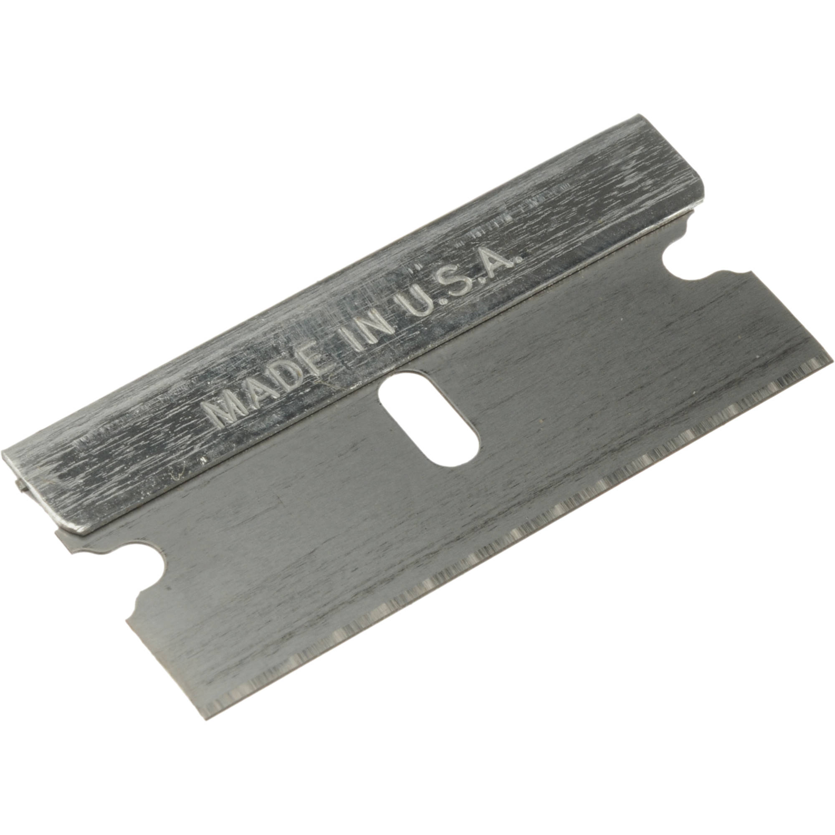 | https://static.bhphoto.com/images/images2000x2000/1340734292_362348.jpg
Broken conical | 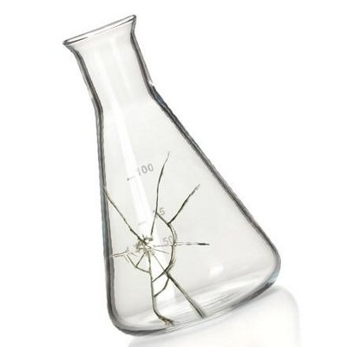 | https://pbs.twimg.com/profile_images/521380344625246209/1R7RQnZh_400x400.jpeg
Cartoon syringe |  | https://cdn2.vectorstock.com/i/1000x1000/81/96/colorful-cartoon-syringe-vector-21698196.jpg
Burn up bin | 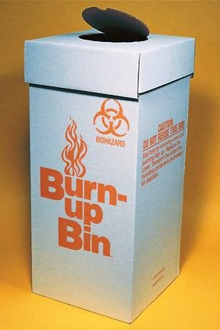 | https://images-na.ssl-images-amazon.com/images/I/41WIhtno28L.jpg
Biohazard bag |  | https://www.medegenmed.com/wp-content/uploads/2015/04/54798_BioH-shadow.jpg
Bio hazard bag knot |  | https://www.meriinc.com/wp-content/uploads/2017/08/IMG_2995-1-e1502389865382.jpg
Env. Hazard sign |  | https://upload.wikimedia.org/wikipedia/commons/thumb/b/b9/GHS-pictogram-pollu.svg/1200px-GHS-pictogram-pollu.svg.png
Toxic hazard sign |  | https://upload.wikimedia.org/wikipedia/commons/thumb/5/58/GHS-pictogram-skull.svg/1200px-GHS-pictogram-skull.svg.png
Biohazard bag goose neck |  | https://www.meriinc.com/wp-content/uploads/2017/08/IMG_2989-e1502388564483.jpg
Biohazard bag goose neck taping |  | https://www.meriinc.com/wp-content/uploads/2017/08/IMG_2995-1-e1502389865382.jpg
Sharps box full | 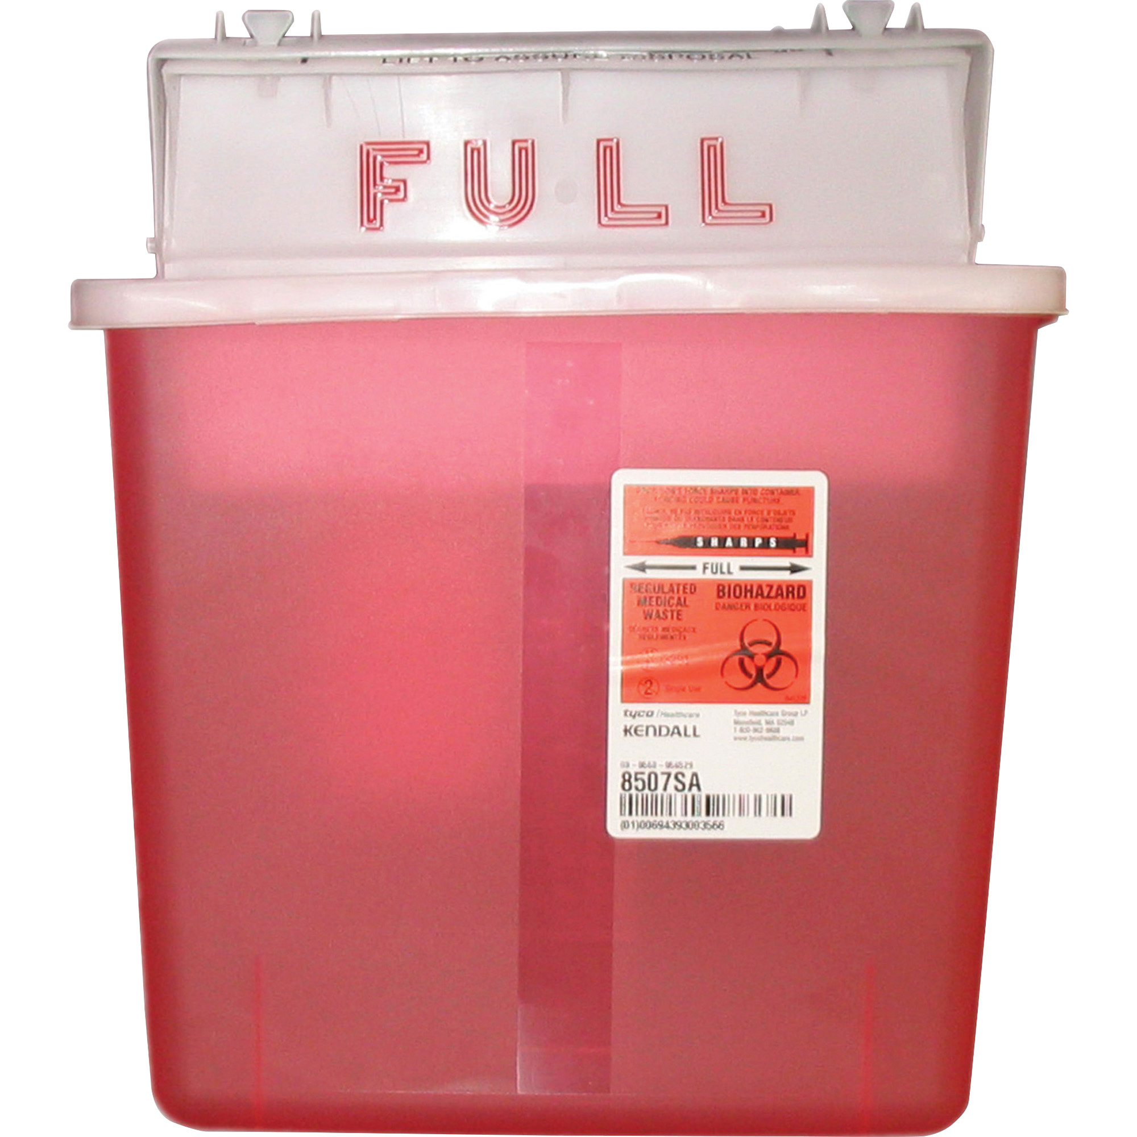 | http://content.etilize.com/Original/1012683558.jpg
Confused lab worker |  | https://media.istockphoto.com/vectors/scientist-in-various-poses-vector-id186266262?k=6&m=186266262&s=612x612&w=0&h=eu6tyJN3iOQx6q7OXRQ8jhH6miacQ8iee0XbjPLAC1g=
Ruptured biohazard bag | 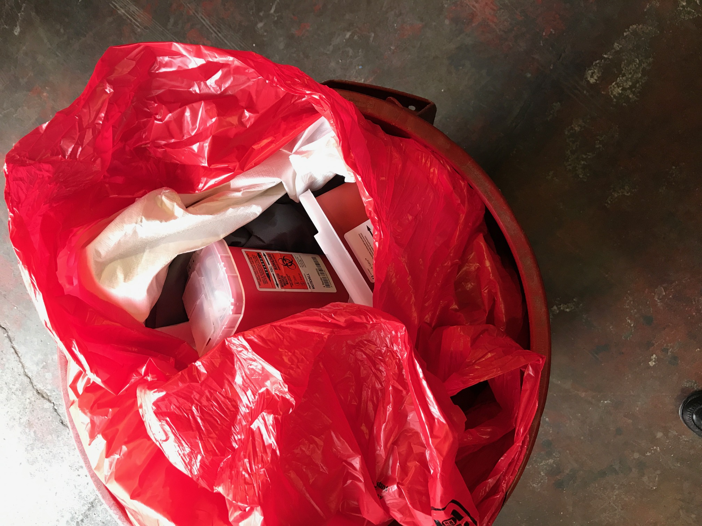 | https://www.meriinc.com/wp-content/uploads/2017/08/IMG_3017.jpg
Bleach |  | https://res.cloudinary.com/teepublic/image/private/s--R8U0iQLr--/t_Preview/b_rgb:ffffff,c_limit,f_jpg,h_630,q_90,w_630/v1493706970/production/designs/1553564_1.jpg
Radioactivity sign |  | http://www.iop.org/resources/topic/img_mid_50697.png
Carcinogen sign |  | http://www.chemistry-blog.com/2012/04/07/what-is-that-thing-the-new-ghs-symbol-for-carcinogens/
White sharps box | 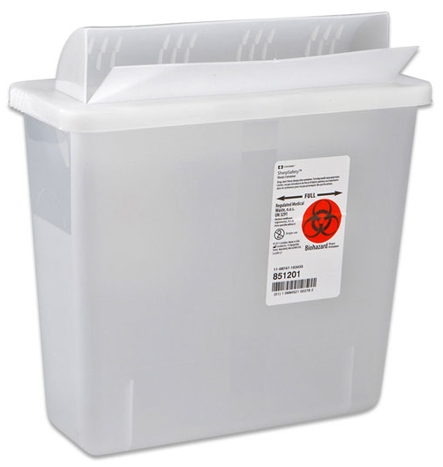 | https://medstatsupplies.com/wp-content/uploads/2017/08/855126-1.jpg
Red sharps box |  | https://www.pocketnurse.com/media/catalog/product/cache/207e23213cf636ccdef205098cf3c8a3/0/3/03-78-1020.jpg
Glass slides | 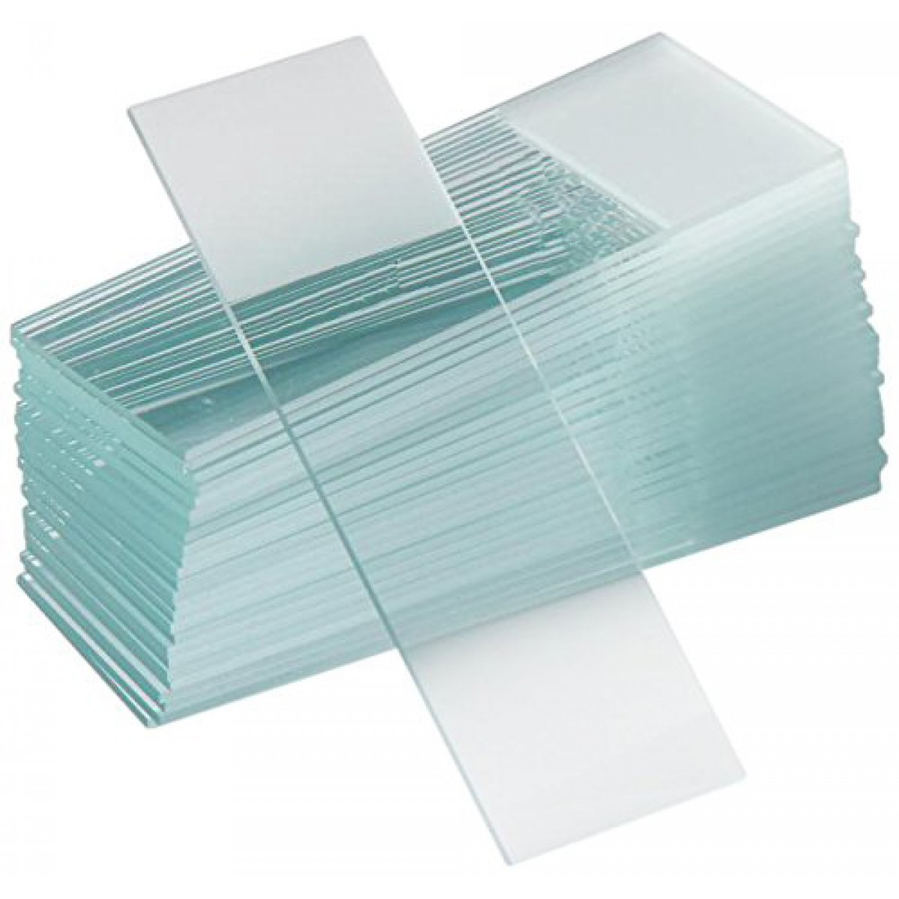 | https://parcoscientific.com/media/catalog/product/cache/1/image/1200x1200/9df78eab33525d08d6e5fb8d27136e95/f/r/frosted_glass_slides.jpg
Cover slips | 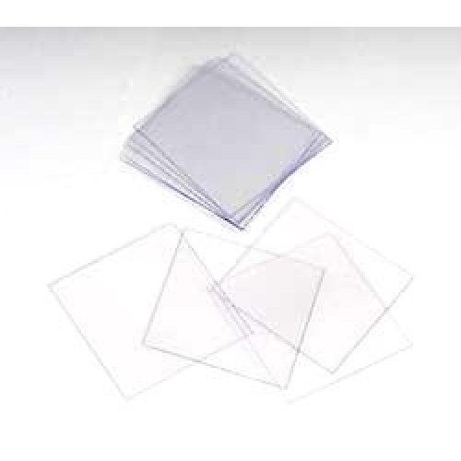 | http://www.dshellsci.com/image-smp/cover-slips-for-microscope-slides-22-x-22-mm-100-pcs_1059_500x500.jpg
Autoclave | 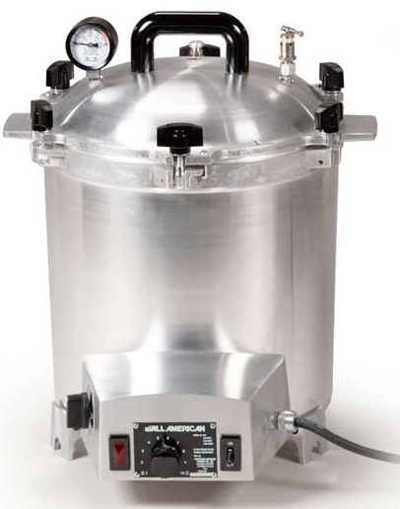 | https://cdn.mysagestore.com/e34a570b1e74d43c3aabf0fe1fe772ab/contents/050119-0004/Small-Benchtop-Autoclave-Sterilizer.jpg
Bleach |  | https://removemoldguide.com/wp-content/uploads/2013/11/shutterstock_57240547.jpg
Blood drop |  | http://lamaison.club/wp-content/uploads/bl/blood-drop-symbol-icon-design-isolated-on-white-vector.jpg
pipettes | 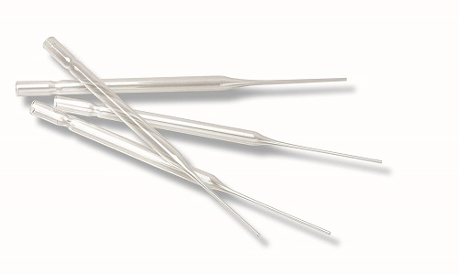 | https://cdn2.hubspot.net/hubfs/2753166/Products/Wheaton%20(DWK)/Disposable_Pipettes_DWK_Pasteur.jpg
Scalpel | 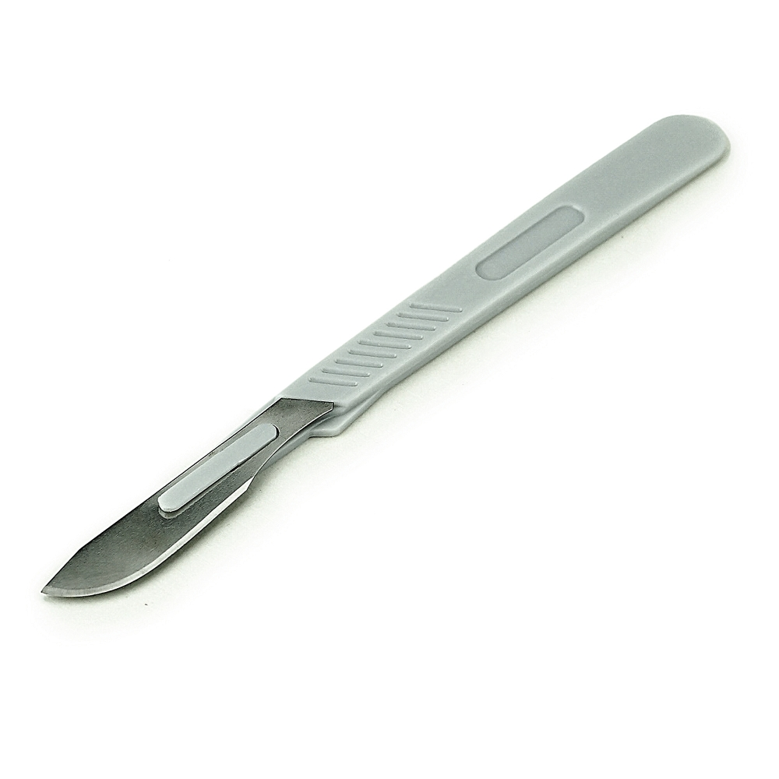 | https://cdn.mysagestore.com/e34a570b1e74d43c3aabf0fe1fe772ab/contents/663-260/DSC00972.JPG
Chemotherapy bin | 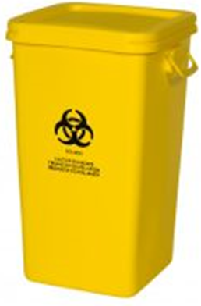 | https://www.meriinc.com/wp-content/uploads/2016/07/yellowchemo38gallon-199x300.jpg
Grey bin |  | https://www.med-flex.com/wp-content/uploads/2015/01/28_gallon_reusable_pathological_container-24_b.jpg
Red bin |  | https://images-na.ssl-images-amazon.com/images/I/31g3mbNDVRL._SY445_.jpg
Blood single tube | 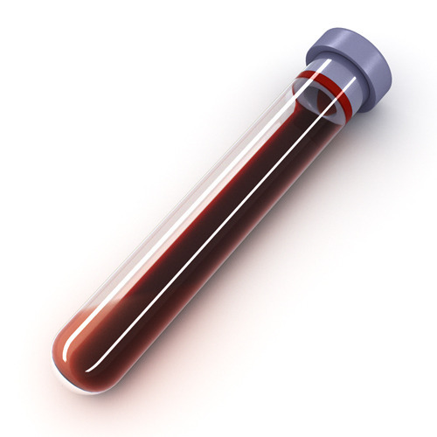 | http://3.imimg.com/data3/LA/WM/GLADMIN-23500/blood-test-tube-500x500.jpg

